|  |  |  |
| --- | --- | --- |
| **شعار جامعة بنها الجديد**f |  |  |
| **Benha University** |  | **Faculty of Computers & Artificial Intelligence** |

**Sign Language**

**Translator**

A senior project submitted in partial fulfillment of the requirements for the degree of Bachelor of Computers and Artificial Intelligence.

**Computer Science Departement,**

***Project Team***

1. Ahmed Mohamed Ahmed Esmail
2. Ahmed Mohamed Shaban Abas
3. Eslam Hamdy Ragab Abd Allah
4. Abdul-Rhman Rashwan Elsaid
5. Omar Ashraf Abd El-Qader Hegab
6. Ghidaa Hisham Abd El-Monem Abd El-Aziz
7. Sherif Alaa Abd El-Monem Mohamed
8. Mustafa Khaled Abdo Mohamed

***Under Supervision of***

**Dr. Rasha Orban**

**Eng: Doaa Mohamed**

DECLARATION

We hereby certify that this material, which we now submit for assessment on the program of study leading to the award of Bachelor of Computers and Artificial Intelligence in *(Bachelor's)* is entirely our own work, that we have exercised reasonable care to ensure that the work is original, and does not to the best of our knowledge breach any law of copyright, and has not been taken from the work of others save and to the extent that such work has been cited and acknowledged within the text of our work.

**Signed:** _____________________________

**Date:** Tuesday, 12 02 2024.

Table of Contents

List of figures Error! Bookmark not defined.

1 Introduction and Background Error! Bookmark not defined.

1.1 INTRODUCTION Error! Bookmark not defined.

1.2 PROBLEM DEFINITION Error! Bookmark not defined.

1.2.1 What is the importance of this problem? **Error! Bookmark not defined.**

1.2.2 What are the current solutions? **Error! Bookmark not defined.**

1.2.3 How will our solution solve the problem? What is new? **Error! Bookmark not defined.**

1.3 SCOPE Error! Bookmark not defined.

2 Analysis and Design Error! Bookmark not defined.

2.1 INTRODUCTION Error! Bookmark not defined.

2.2 USER AND SYSTEM REQUIREMENTS Error! Bookmark not defined.

2.2.1 User Requirements **Error! Bookmark not defined.**

2.2.2 Functional Requirements **Error! Bookmark not defined.**

2.2.3 Non-functional Requirements **Error! Bookmark not defined.**

2.3 STACKHOLDERS Error! Bookmark not defined.

2.3.1 Supervisor **Error! Bookmark not defined.**

2.3.2 AI System **Error! Bookmark not defined.**

2.4 SYSTEM DESIGN Error! Bookmark not defined.

2.4.1 Gantt Chart **Error! Bookmark not defined.**

2.4.2 Use Case Diagram **Error! Bookmark not defined.**

2.4.3 Activity Diagrams 20

2.4.4 Class Diagram **Error! Bookmark not defined.**

2.4.5 Sequence Diagrams **Error! Bookmark not defined.**

2.4.6 State Diagrams **Error! Bookmark not defined.**

2.4.7 Data Flow Diagrams **Error! Bookmark not defined.**

2.5 USED TECHNOLOGIES AND TOOLS Error! Bookmark not defined.

2.5.1 Hardware **Error! Bookmark not defined.**

2.5.2 Software **Error! Bookmark not defined.**

2.6 SUMMARY Error! Bookmark not defined.

3 IMPLEMENTATION AND EVALUATION Error! Bookmark not defined.

3.1 INTRODUCTION Error! Bookmark not defined.

3.2 DATASETS Error! Bookmark not defined.

3.3 PREPROCESSING DATA Error! Bookmark not defined.

3.3.1 Resize and Normalization **Error! Bookmark not defined.**

3.3.2 Data Augmentation **Error! Bookmark not defined.**

3.3.3 Pose Estimation Using Open Pose **Error! Bookmark not defined.**

3.3.4 Using YOLOv3 Pre-Trained Model **Error! Bookmark not defined.**

3.4 Modeling Error! Bookmark not defined.

3.4.1 Custom CNN Model **Error! Bookmark not defined.**

3.4.2 CONV1d + SVM **Error! Bookmark not defined.**

3.4.3 VGG-16 Model **Error! Bookmark not defined.**

3.4.4 MobileNet and ResNet **Error! Bookmark not defined.**

3.5 TESTING AND EVALUATION Error! Bookmark not defined.

3.6 SUMMARY Error! Bookmark not defined.

4 DISCUSSION AND CONCLUSION Error! Bookmark not defined.

4.1 INTRODUCTION Error! Bookmark not defined.

4.2 MAIN FINDINGS Error! Bookmark not defined.

4.2.1 Why Is This Project Important **Error! Bookmark not defined.**

4.2.2 Practical Implementations **Error! Bookmark not defined.**

4.3 LIMITATIONS Error! Bookmark not defined.

4.4 FUTURE RECOMMENDATION Error! Bookmark not defined.

4.5 SUMMARY Error! Bookmark not defined.

5 References Error! Bookmark not defined.

# **1 Introduction and Background**

# **1.1 Introduction**

In a world where effective communication is paramount, the Sign Language Translator project stands as a pioneering effort to bridge the communication gap for the deaf community.

This initiative aims to provide an accessible and user-friendly solution for seamless communication between individuals with hearing impairments and the broader society. Whether manifested as a mobile application or a web page, the potential application relies on cutting-edge artificial intelligence technology to convert textual inputs into sign language.

Distinguished by an AI-driven model, the project excels in analyzing textual inputs with precision, translating them into sign language accurately and efficiently. Additionally, the application grants access to the camera, allowing the conversion of sign language into text, thereby opening new avenues for interaction with the surrounding environment.

The interface is designed to be simple and intuitive, ensuring user-friendly navigation, with customizable settings to cater to individual needs.

The project endeavors to enhance communication for the deaf community, fostering a sense of inclusivity and contributing to an improved quality of daily life. Join us on this transformative journey as we strive to make communication a universal right for everyone, transcending barriers and fostering a more connected and inclusive world.

# **1.2 Problem Definition:**

1. **Description of the Problem:**

* The project aims to develop a Sign Language Translation that facilitates communication between individuals who use sign language and those who do not. The goal is to bridge the communication gap and provide a seamless means for sign language users to interact with the broader community.

1. **Scope of the Problem:**
   * The scope includes the development of a real-time sign language translation system that can interpret and convert sign language gestures into spoken or written language.
2. **Objectives and Goals:**

* Enable effective communication for deaf or hard of hearing individuals in various settings, including educational institutions, workplaces, and social environments.
* Develop a user-friendly interface that accommodates both sign language users and those unfamiliar with sign language.
* Provide accurate and timely translation of sign language gestures to spoken or written language.

1. **Constraints and Limitations:**

* The system must operate in real-time to ensure effective and natural communication.
* Consideration of different dialects and variations within the chosen sign language.
* Accessibility requirements, ensuring the system is usable by individuals with varying levels of technological proficiency.

1. **Stakeholders and Users:**

* Primary stakeholders include those deaf or hard of hearing.
* Secondary stakeholders include educators, employers, and community members interested in fostering inclusive communication.

1. **Functional Requirements:**

* Capture and interpret sign language gestures through computer vision or similar technology.
* Translate interpreted gestures into spoken language or text.
* Provide a user interface that is intuitive for both sign language users and non-sign language users.

1. **Non-functional Requirements:**

* Ensure high accuracy in gesture recognition to minimize misinterpretations.
* Minimize latency to achieve real-time communication.
* Implement security measures to protect user privacy and data.

1. **Assumptions and Risks:**

* Assumption: Adequate training data for the chosen sign language will be available.
* Risk: Variability in individual signing styles may pose challenges for accurate interpretation.

1. **Success Criteria:**

* Positive feedback from end-users regarding the system's usability and effectiveness.

# **Problem Solution:**

**1.3.1 Proposed Solution:**

* Develop a Sign Language Translation that employs a combination of computer vision, machine learning, and natural language processing techniques to accurately interpret sign language gestures in real-time. The system will then translate these gestures into spoken language or text, providing a seamless means of communication for individuals who use sign language.
  + 1. **Technical Approach:**
* Computer Vision: Utilize computer vision algorithms to capture and analyze sign language gestures through video input.
* Machine Learning: Implement machine learning models trained on diverse datasets to enhance the system's accuracy and adaptability to individual signing styles.
* Natural Language Processing: Employ natural language processing algorithms to convert interpreted gestures into spoken language or written text.
  + 1. **System Architecture:**
* The system will consist of a camera or sensor to capture sign language gestures.
* Computer vision algorithms will preprocess and interpret the gestures.
* Machine learning models will refine the interpretation based on individual user patterns.
* The translated output will be presented through a user-friendly interface, including spoken language output and/or on-screen text.
  + 1. **User Interface Design:**
* Develop an intuitive interface that accommodates both sign language users and non-sign language users.
* Include visual feedback to confirm the system's understanding of gestures.
* Provide options for customization, allowing users to adapt the system to their individual preferences.
  + 1. **Testing and Validation:**
* Conduct rigorous testing using diverse datasets to train and evaluate the machine learning models.
* Perform user testing with individuals who use sign language to validate the system's accuracy and usability.
* Iterate on the system based on user feedback to continuously improve performance.
  + 1. **Accessibility and Inclusivity:**
* Ensure the system is accessible to individuals with varying levels of technological proficiency.
* Implement features that consider different dialects and variations within the chosen sign language.
* Prioritize user privacy and data security in the design and implementation.
  + 1. **Deployment and Scalability:**
* Develop the system with scalability in mind to accommodate potential expansion to other sign languages.
* Plan for easy deployment in diverse settings, including educational institutions, workplaces, and community spaces.
  + 1. **Monitoring and Maintenance:**
* Implement monitoring tools to track system performance and user feedback.
* Establish a maintenance plan to address issues, update models, and incorporate improvements over time.
  + 1. **Expected Outcomes:**
* Positive feedback from end-users regarding the system's usability and effectiveness.
* Increased accessibility and inclusivity in communication for individuals who use sign language.
  1. **Scope:**
     1. **Objective:**
* Develop an advanced Sign Language Translator application that enables seamless communication between individuals with hearing impairments and the broader community.
* Provide a user-friendly interface for text-to-sign language and sign language-to-text translations, supporting inclusivity and accessibility.
  + 1. **Location:**
  + The project will be designed as a mobile application and a web page, ensuring accessibility across various devices and platforms.
    1. **Budget:**
  + Allocate resources for the development, testing, and implementation phases.
  + Account for potential expenses related to AI model development, server hosting, and platform compatibility.
    1. **Milestones:**
  + Define key milestones, including the completion of AI model development, implementation of translation features, user interface design, testing phases, and the launch of the application.
    1. **Main Stakeholders:**
  + Deaf and hard-of-hearing individuals.
  + Developers and project management team.
  + Potential investors or funding sources.
  + User experience and accessibility experts.
    1. **Projects Parts/Components:**
  + Text-to-Sign Language Translation Module.
  + Sign Language-to-Text Translation Module.
  + User Interface Design.
  + Camera Integration Module.
  + Cross-Platform Compatibility Module.
  + Security and Privacy Features.
  + Testing and Quality Assurance.
    1. **Project Description:**
  + The project aims to create a state-of-the-art Sign Language Translator application, leveraging AI for accurate translation between text and sign language. The user-friendly interface and camera integration facilitate dynamic and inclusive communication.
    1. **Type of Works (BOQ - Bill of Quantities):**
  + Specify the quantity and types of resources needed for AI model development, server hosting, software development, and testing.
    1. **Roles and Responsibilities for Different Parties:**
  + Developers: Responsible for AI model development, software coding, and application testing.
  + Project Management Team: Oversee project timelines, milestones, and resource allocation.
  + User Experience Experts: Ensure the design meets accessibility standards and provides an optimal user experience.
  + Investors/Funding Sources: Provide financial support for the project.
  + Testing Team: Conduct thorough testing to identify and resolve any issues before the application launch.

By addressing these components within the project scope, you establish a comprehensive framework that guides the development and implementation of the Sign Language Translator application.

# **2.1 Use Case Diagram**

The Sign Language Translator Software accommodates four distinct user roles Admin, Guest (Gest), Normal User, and Deaf User. This platform encompasses 15 essential functions to enhance communication between sign language speakers and non-sign language speakers. Below is an elaboration of the primary components and functions captured in the use case diagram:

* + 1. **User Roles:**
  + **Admin:** System administrator responsible for managing courses and user accounts.
  + **Guest (Gest):** Unregistered users exploring the system without authentication.
  + **Normal User:** Authenticated users interested in learning sign language and utilizing translation features.
  + **Deaf User:** Users who are deaf and rely on sign language for communication.
    1. **Use Cases:**
  + **Login:** Allows users to securely log into their accounts.
  + **Registration:** Enables new users to create accounts within the system.
  + **Reset Password:** Provides a mechanism for users to reset their passwords securely.
  + **Translate Sign to Text:** Converts sign language gestures into textual information for non- sign language speakers.
  + **Translate Text to Sign:** Transforms textual input into sign language gestures for sign language speakers.
  + **Education:** Offers educational resources and tutorials for users to learn sign language.
  + **Add Course:** Allows administrators to add new sign language courses to the system.
  + **Edit Course:** Permits administrators to modify existing course content.
  + **Remove Course:** Enables administrators to delete courses from the system.
  + **Support:** Provides a support system for users to seek assistance.
  + **Chat:** Facilitates real-time communication between users and support personnel.
  + **View Progress in Course:** Allows users to track their progress within enrolled courses.
  + **View Courses:** Displays a list of available sign language courses.
  + **View User Information:** Provides users with access to their account information.
  + A diagram of a sign language translator

    Description automatically generated**Delete Account:** Allows users to permanently delete their accounts.

|  |  |
| --- | --- |
| Use Case ID | 1 |
| Use Case name | Registration |
| Actors | Normal user, Deaf user, Guest. |
| Preconditions | None. |
| Normal Flow | 1. User clicks on Sing Up button. 2. User fills in his/her information. 3. Users receive confirmation E-mail. 4. The system displays the Sign Translation page. |
| Post conditions | 1. Open Home page 2. The user’s details are stored in the database. |
| Alternative Flow | The information already exists. |

|  |  |
| --- | --- |
| Use Case ID | 2 |
| Use Case name | Login |
| Actors | Admin, Normal User, Deaf User. |
| Preconditions | Admin, Normal User and Deaf User need to complete the registration process. |
| Normal Flow | 1.Insert Username.  2.Insert Password.  3.Login. |
| Post conditions | Login Successfully. |
| Alternative Flow | 1.Insert the Incorrect Username.  2.Insert the Incorrect Password. |

|  |  |
| --- | --- |
| Use Case ID | 3 |
| Use Case name | Reset Password |
| Actors | Admin, Normal User, Deaf User. |
| Preconditions | Admin, Normal User and Deaf User Must do Registration. |
| Normal Flow | 1.Insert Username.  2.Insert Email Address.  4.Change Password.  5.Password Reset. |
| Post conditions | Password has been Reset. |
| Alternative Flow | 1.Insert the Incorrect Username.  2.Insert the Incorrect Email Address.  3.Insert the Same Old Password. |

|  |  |
| --- | --- |
| Use Case ID | 4 |
| Use Case name | Translate From Sign to Text |
| Actors | Normal User, Guest |
| Preconditions | Normal User or Guest must enter the sign which he wants to translate to text |
| Normal Flow | 1. Enter the sign you want to translate to text 2. Return text |
| Post conditions | Translate from sign to text successful |

|  |  |
| --- | --- |
| Use Case ID | 5 |
| Use Case name | Translate From Text to Sign |
| Actors | Deaf User, Guest |
| Preconditions | The Deaf User or the Guest must enter the text which he wants to translate to sign |
| Normal Flow | 1. Enter the text you want to translate to sign 2. Translate |
| Post conditions | Translate from text to sign successful |
| Alternative Flow | * did not enter any text or enter a not understood text |

|  |  |
| --- | --- |
| Use Case ID | 6 |
| Use Case name | Education |
| Actors | Normal user, Deaf user |
| Preconditions | Users must log in first to access the educational platform.  Course content is available for the selected course. |
| Normal Flow | 1. User selects a course.  2. User views course content and interacts with it. |
| Post conditions | The user successfully accesses and interacts with the course content. |
| Alternative Flow | In case of technical issues, the user is redirected to a support page. |

|  |  |
| --- | --- |
| Use Case ID | 7 |
| Use Case name | Add Course |
| Actors | Admin |
| Preconditions | Admin must log in first to access the course management system. |
| Normal Flow | 1. Admin navigates to the "Add Course" section.  2. Admin provides course details.  3. Admin click on “Add Course” button.  4. The system verifies and stores the course information. |
| Post conditions | The new course has been successfully added to the system. |
| Alternative Flow | If there are any validation errors (missing information or duplicate course name), the system prompts the admin to correct the errors and resubmit. |

|  |  |
| --- | --- |
| Use Case ID | 8 |
| Use Case name | Remove courses |
| Actors | Admin |
| Preconditions | The admin must enter the course code to remove it |
| Normal Flow | 1- Admin login.  2-Admin click on delete course tap  3- Confirm the admin identity  4-Admin enter course code  5-Admin click on delete button |
| Post conditions | Course deletes successful |
| Alternative Flow | have not entered the course code or entered the course code incorrectly |

|  |  |
| --- | --- |
| Use Case ID | 9 |
| Use Case name | Modify courses |
| Actors | Admin |
| Preconditions | The admin must enter the course code to modify it |
| Normal Flow | 1- Admin login.  2-Admin click on modify course tap  3- Confirm the admin identity  4-Admin enter course code  5-Admin click on modify button |
| Post conditions | Courses modify successful |
| Alternative Flow | have not entered the course code or entered the course code incorrectly |

|  |  |
| --- | --- |
| Use Case ID | 10 |
| Use Case name | Technical Support |
| Actors | Normal User, Deaf User, Guest, Admin. |
| Preconditions | Normal User, Deaf User and Guest request support. |
| Normal Flow | 1. Request support. 2. Wait for answers. |
| Post conditions | Manage Support Requests. |
| Alternative Flow | -If there are technical issues with the request submission:  1-The system displays an error message.  2-The user is instructed to try again later. |

|  |  |
| --- | --- |
| Use Case ID | 11 |
| Use Case name | Chat |
| Actors | Normal User, Deaf User, Guest. |
| Preconditions | Normal User, Deaf User and Guest must do registration. |
| Normal Flow | 1. Login 2. Go to chat section or Search for any account. 3. Start chat |
| Post conditions | Message sent successfully. |
| Alternative Flow | * Faild to send message. |

|  |  |
| --- | --- |
| Use Case ID | 12 |
| Use Case name | progress in courses |
| Actors | Normal user, deaf user |
| Preconditions | View courses and learn through them in the system |
| Normal Flow | 1. view courses 2. learning 3. show progress in courses |
| Post conditions | Log out (optional) |
| Alternative Flow | no courses added by admin |

|  |  |
| --- | --- |
| Use Case ID | 13 |
| Use Case name | View courses |
| Actors | Normal user, deaf user |
| Preconditions | Normal User and Deaf User Must do Registration and log in successfully  Admin must add course  Normal User, Deaf User must progress in courses |
| Normal Flow | 1. User login 2. view courses |
| Post conditions | Access the courses through which we Learn |
| Alternative Flow | no courses exist |

|  |  |
| --- | --- |
| Use Case ID | 14 |
| Use Case name | View Information |
| Actors | Admin |
| Preconditions | User Must be Logged in As Admin |
| Normal Flow | 1. Admin login. 2. Click on View profiles button. 3. Search for the profile he wants to view 4. Display User profile |
| Post conditions | View user profile |
| Alternative Flow | The user does not exist |

|  |  |
| --- | --- |
| Use Case ID | 15 |
| Use Case name | Delete Accounts |
| Actors | Admin, Normal User, Deaf User |
| Preconditions | User must be logged in |
| Normal Flow | 1. Click on view profile button. 2. Click on delete account button. 3. Confirm deleting account by entering account password |
| Post conditions | Account deleted successfully |
| Alternative Flow | Account password is incorrect |

**2.2 Activity Diagrams**

The Activity Diagram explains the operations that are carried out on each process, and I see the validation, The powers, and how will the system work, In the case of success, one thing is done, and in case of failure, another thing is done.

* + 1. A diagram of a computer program

       Description automatically generated**Registration:**

Users are required to provide relevant information such as personal details and contact information.

Once the necessary information is entered,

users will typically need to create a username and password, followed by verification steps to ensure the accuracy of the provided details.

After successfully completing these steps,

users gain access to the platform or system with their unique credentials.

* + 1. **Login:**

The login process typically follows the registration process and involves users accessing the Application or Website using their previously created credentials.

* + 1. **Reset Password:**

* + 1. **Translate from sign to text:**

* + 1. **Translate from text to sign:**

* + 1. **Education:**

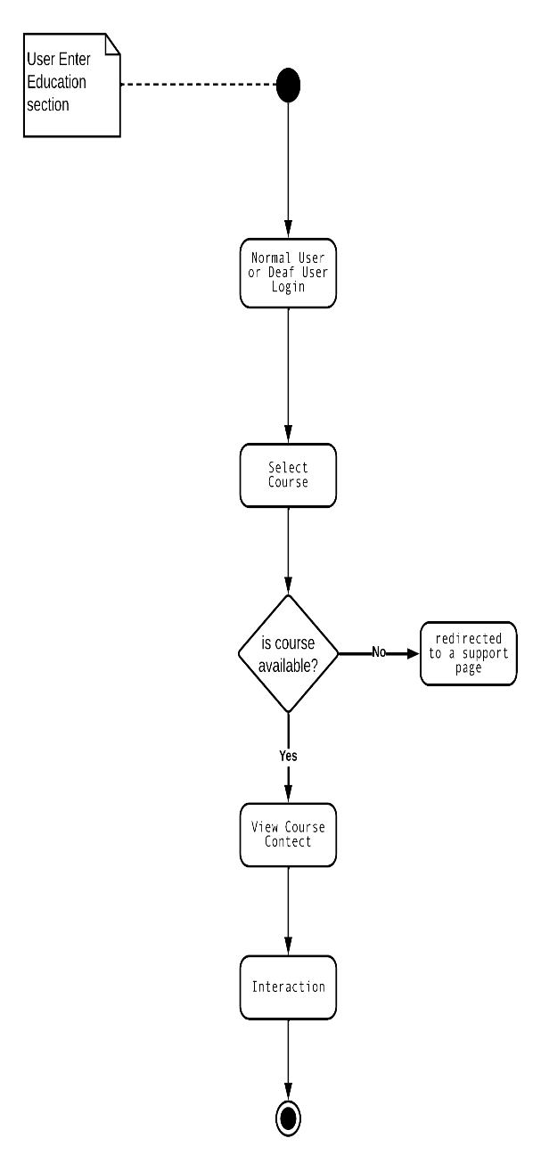

As the user explores the education section, he begins by logging in, the user first must login to view the course and start to learn. After that, he picks a course he is interested in. The system then checks if the chosen course is available. If it is, the user moves forward; if not, he is redirected to a support page for assistance. Once the course is confirmed available, the user gets access to its content. He can then interact with the material, participating in discussions and completing assignments, making the learning experience engaging and inclusive.

* + 1. **Add Course:**

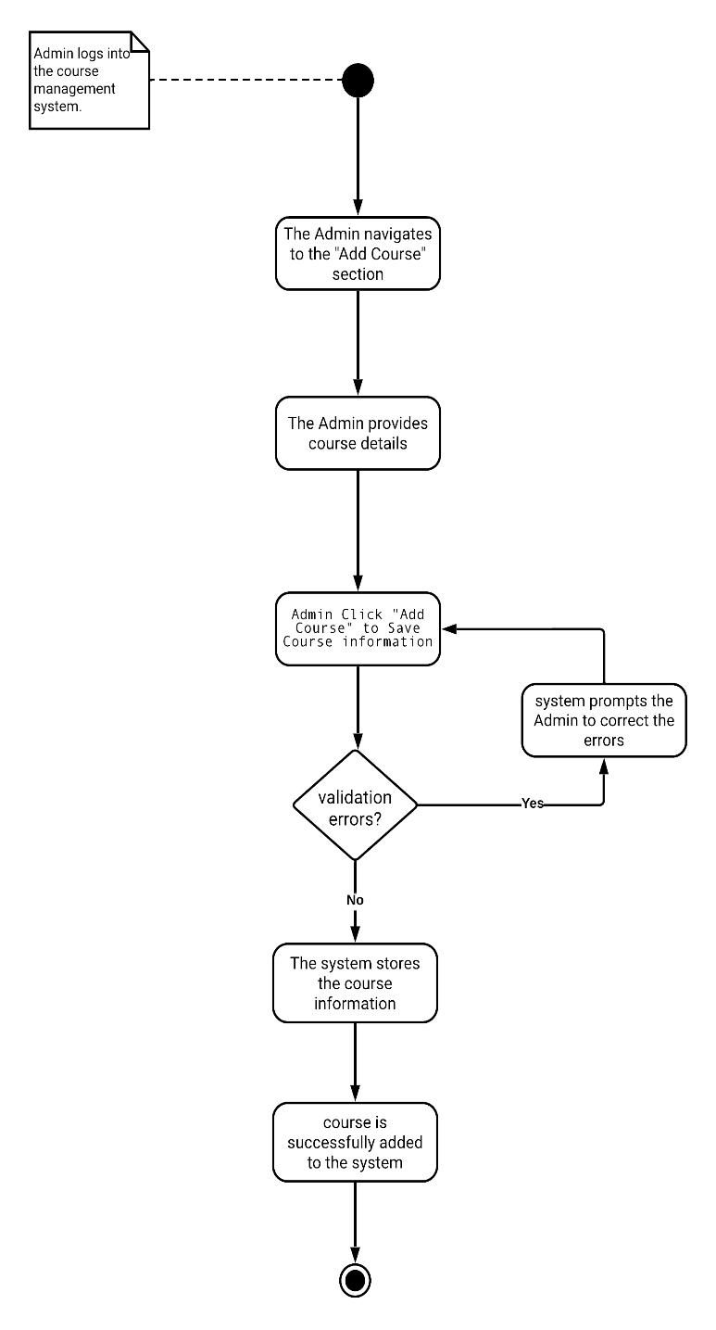

The course addition process starts with the admin logging into the course management system. The admin then goes to the section where courses can be added and provides necessary details like the course name and description. Clicking on "Add Course" saves this information.

The system checks for errors. If there are any, it asks the admin to fix them. If everything is error-free, the system stores the course details in the database. The activity concludes with a confirmation message, indicating that the course has been successfully added to the system.

**2.2.8 Remove courses**

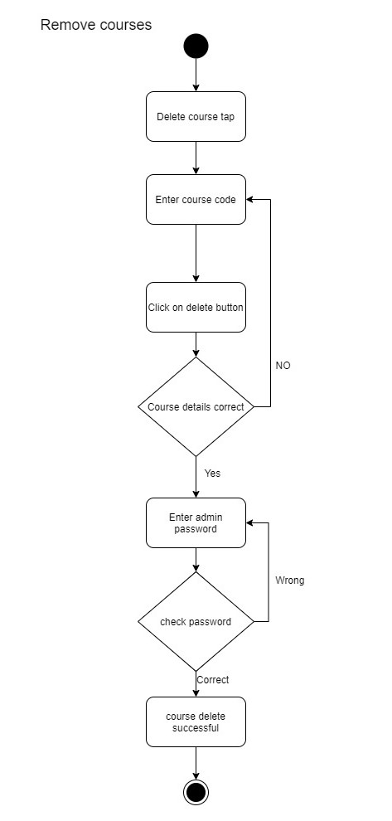The course Remove process starts with the admin logging into the course management system. The admin then goes to the section where courses can be removed and provides necessary details like the course id. Clicking on "Delete Course" removes this information. The system checks for errors. If there are any, it asks the admin to fix them. If everything is error-free, the system removes the course from the database. The activity concludes with a confirmation message, indicating that the course has been removed.

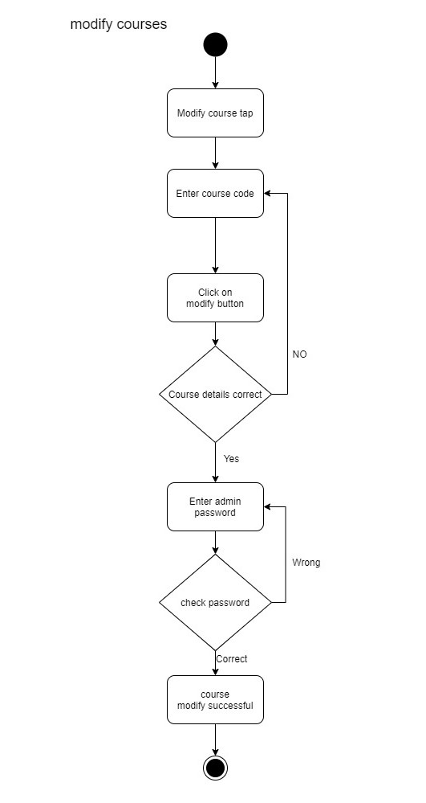**2.2.9 modify courses** The course modify process starts with the admin logging into the course management system. The admin then goes to the section where courses can be modify and provides necessary details like the course id, name and description. Clicking on "Modify Course" modifies course information. The system checks for errors. If there are any, it asks the admin to fix them. If everything is error-free, the system modify the course in the database. The activity concludes with a confirmation message, indicating that the course has been modify.

**2.2.10**  **Support**

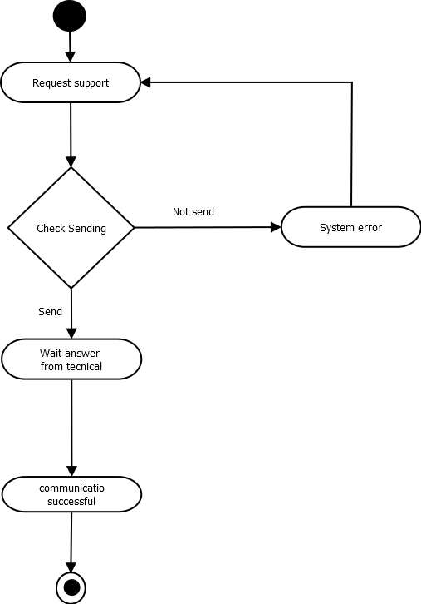

Technical Support

**2.2.11 Chat**

Chat

**2.2.12 Progress in Course**

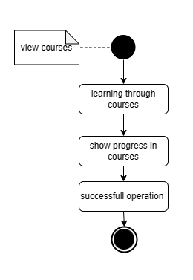

Normal,deaf users can see their progress in learning the courses

progress in courses means how much user has learned from the entire course

In the beginning, you must show the available courses and then choose the appropriate course for you so that you can learn from it and follow in its footsteps. By continuing your learning, you can see the extent of your progress in the course and how much you have accomplished from it

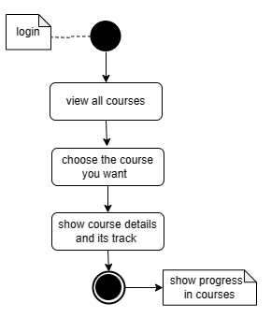

13 - View courses

One of the goals of the project is to teach deaf and normal users sign language, which is done through courses. so, the user must view these courses. The user logs into his account

,Then he chooses view courses, through which all the courses in the system that are available to the user are displayed

,The user chooses the course he wants

,The details of this course and the educational path it will follow are displayed

**2.2.14 View Information:**

The Admin Can View Any User Information Like

* Name
* Profile photo
* Gender
* And Enrolled courses

To view the information The admin must search for the user using his username.

If the username exists, the system will show the user information.

If Ther is no user with This username the system will show a message That The user doesn’t Exist and Back again to Search page

**2.2.15 Delete Account**

The Admin can Delete user’s Account by searching for the user then viewing it’s account After Viewing Account Ther is a button For deleting Account.

To delete Any user Account The admin must Enter his password to confirm deletion:

* If the password isn’t correct the system will ask for the admin to Enter password Again
* If the password is correct the user will be deleted permanently

Deleting user Account is permanent and will delete any data related to the user like enrolled courses, progress in courses, profile photo, etc...

2.3 Class Diagram:

2.4 Sequence Diagram:

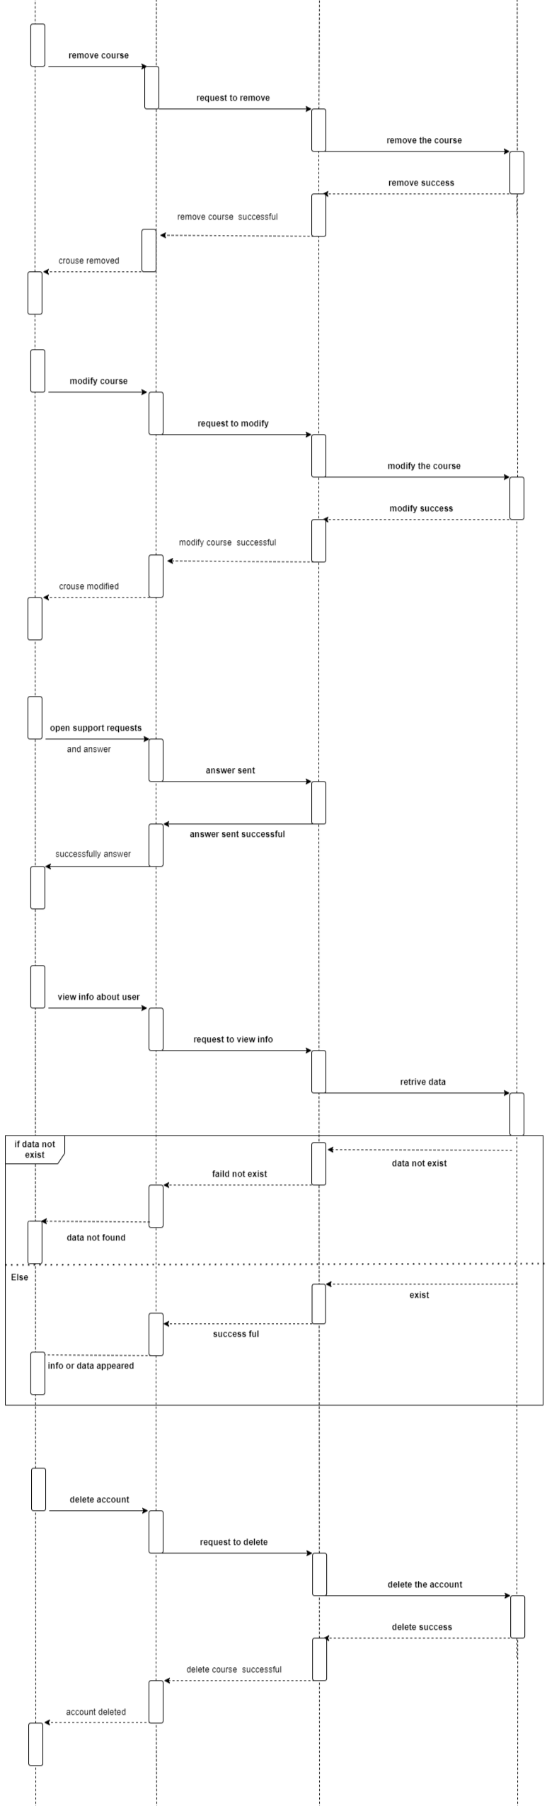

Context Diagram:

Data Flow Diagram:

**ER Diagram:**

